Mobile Inventory Control System
Guidelines for your Dealership

Before beginning the actual physical action of taking inventory, there are some steps to follow to assure a quality result. Please refer to the Netview Physical Inventory Manual for in-depth instructions of the following reports.
- Print the Negative On Hand Report
- Print the Report Writer Report Parts With No Bin Locations
- Print the On Order Report
- Clean up the Picking Ticket File
- Print the Parts Value Report
- Become familiar with the inventory gun and read these guidelines before using it.
To begin taking inventory, tap twice on the HBSMobile Icon on the display panel.

HBS Mobile Central
SHORTCUT
TO
HBSMOBILE

HBS Mobile Central

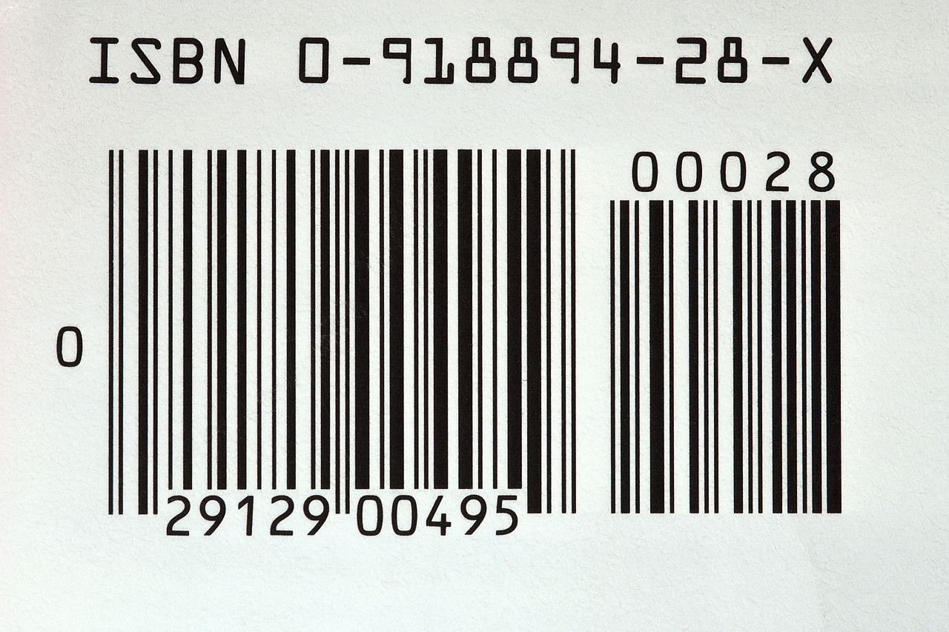

Using the Gun
Overview of Key Pad & Input Panel

Turn the gun on by pressing the small red button in the lower right-hand corner of the pad.
If not used for a period of time, the screen fades to black. Press the yellow bar on the top row of buttons to reactivate it. Touching the screen with the stylus will also return you to the display mode. To access the lighting function, press My Device, Control Panel and then BackLight. Select your preferences from the options.
The device will shut off based after a pre-set amount of time. To access the shut-off options, press My Device, Control Panel and then Power.
To delete an entry, run the stylus across the error. When darkened, enter the correction or new data.
To move the cursor to a field, tap the field with the stylus.
Input Panel Functions (small keyboard w/stylus)
To access the Input Panel, tap the middle small icon on the bottom row of most screens.
Press escape to return to the main screen.
Tab moves around the inventory screen.
Cap turns all letters to upper case. Touch it again and it returns to lower case.
Shift gives you more characters, i.e., #, @, etc.

Key Pad Functions
To change the key pad from numeric to an alpha charactesr, press the orange ALPHA key. Note that the letters are directly above the other keys on the pad. To change back to numeric, press the ALPHA button again. ALPHA displays in the lower right hand corner when in Alpha mode. There is no display when in numeric mode.
The ENT key is used the same as the Enter key on a standard computer.

Using the Gun For
Parts Inventory

Tap the MOBILE PARTS button twice with the stylus.

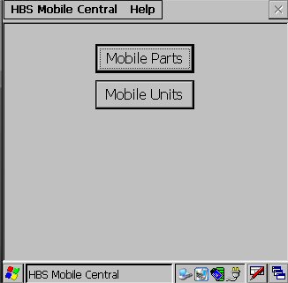
You may be asked to enter a password. Enter it and press the ok button. The inventory screen will open.
IMPORTANT: If you have a multi-location dealership, you will need to select the location where you are performing inventory. This is done by tapping twice on the HBS Mobile Central field at the top of the screen and selecting the store you are inventorying.

Example of Parts Inventory Screen:

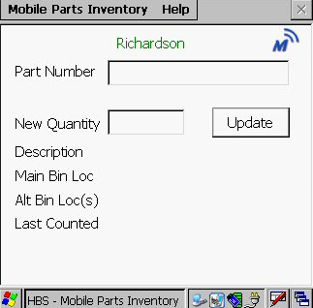

Access to: Power Setting
Access Input Panel
Menu

Point the inventory gun at the barcode and squeeze the handle. The part information will fill the fields, allowing you to confirm the quantity. Count the quantity on hand and enter the number. When you have entered it, press update. You will see a small green checkmark next to the Update Field confirming the current count has been entered. Your inventory is instantly updated! If there is no a bar code, you can enter the part number and count using the keypad or Input Panel. Press Enter on the keypad and update it from the Input Panel.

To scan (or manually enter) an additional part number, use the stylus to drag across the current part number. It will darken. Scan the next part and it will replace the previous part’s information.

Parts Inventory
Reporting

Parts Inventory

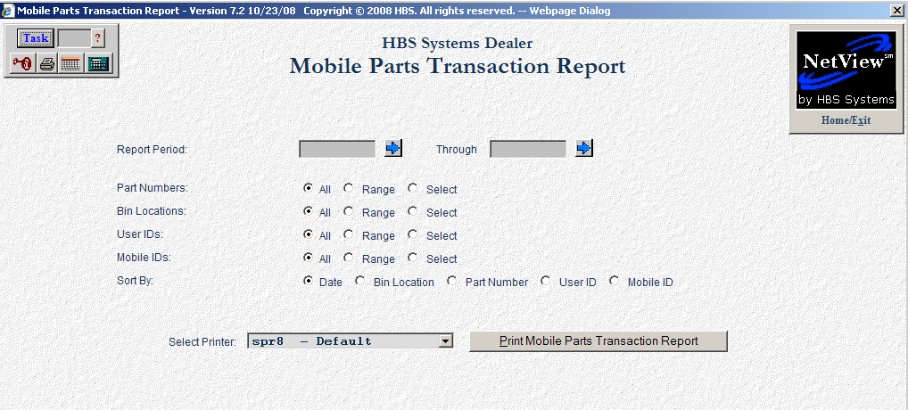
We recommend that you run the Mobile Parts Transaction Report for the inventory just completed. Customize this report to best meet your reporting needs and post-inventory follow up activity. To access this report, select the following from the drop down menu:
Parts Inventory Menu / Physical Inventory / Mobile Parts Transaction Report
Or type MPTR in the task box

Field Definitions

Report Period
Define the dates for the period of time to be included in this report. Choose a starting and ending date or use the arrow to the right to access a calendar.

Part Number
This selection lets you refine the details for the report. For the date range selected, you may choose all part numbers, a range of part numbers or up to six selected numbers.
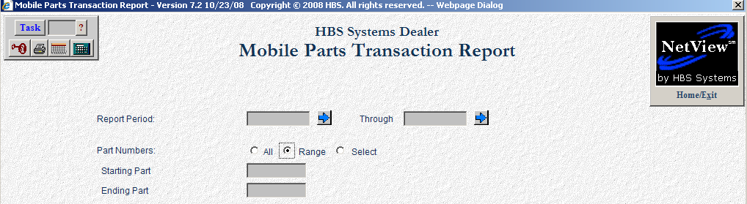

Bin Location
For the date range selected, you may choose all bin locations, a range of bin locations or up to six specific bin locations.

User Ids
For the date range selected, you may choose all user ids, a range of user ids or up to six specific user ids.

Mobile Ids
For the date range selected, you may choose all mobile ids, a range of mobile ids or up to six specific mobile ids.

Sort By
Choose the method of sorting for the report – date, bin location, part number, user id or mobile id.

Select Printer
Select the printer to receive the printout. A default printer name is pre-filled but can be changed as necessary using the pull-down menu. Use the see printer to view the report on the screen without printing a copy of it.

Print Mobile Parts Transaction Report (Alt P)
Press this button to print the report.
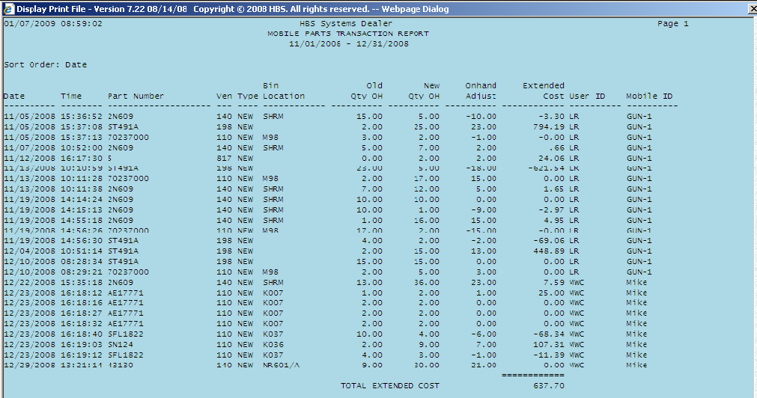
Example of a Mobile Parts Inventory Report

Report Fields

Report Period
This shows the date range selected for the report.

Sort Order
This is the sorting selection for the report.

Date
The date shown is when the inventory was taken.

Time
This shows the time of day the inventory was taken.

Part Number
This is the part number that was counted.

Ven
The vendor number for this part is listed here.

Type
This field identifies the part type. This can be new, used, core, reman or memo.

Bin Location
This is the primary location of the part.

Old Qty OH
This is the number on hand before the new count is entered.

New Qty OH
The number of the parts counted during inventory is reported here.

Onhand Adjust
This is the difference between the Old Qty OH and New Qty OH.

Extended Cost
This is the extended cost of the amount of the adjustment. It is calculated by multiplying the on hand adjustment multiplied by the cost per part.

User ID
This is the logon of the person who took the inventory.

Mobile ID
This is the identification assigned to the Mobile Unit.

Using the Gun For
Units Inventory

BEFORE STARTING, PLEASE READ THE OVERVIEW ON PAGES 1 AND 2.

Tap the MOBILE UNITS button twice with the stylus.

You may be asked to enter a password. Enter it and press the ok button. The inventory screen will open.

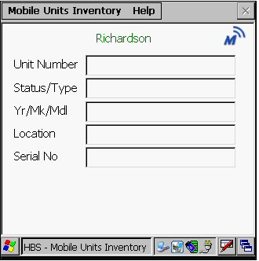

IMPORTANT: You must download the unit files before beginning your inventory so that the units can be recognized. Press on HBS Mobile Central at the top of the screen. Select DOWNLOAD UNIT FILE from the drop down menu. Wait for the file to download.

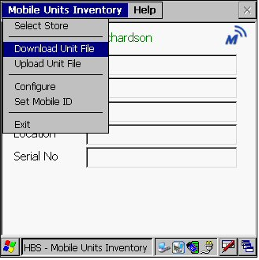
Point the inventory gun at the barcode and squeeze the handle. The information describing the unit will fill the fields allowing you to confirm the unit. When the scan has been successful, “Scan Recorded” will appear on your screen.

This is an example of a successful scan:

HBS Mobile Central Help
Unit Number
  40385
Status/Type
  New Loader
Yr/MK/Md
  2008 NH 110TL
Location
  CONSOLIDAT
Serial No.
  39847890

SCAN RECORDED
HBS Mobile Central

To scan another unit, use the stylus to drag across the current unit number and darken it. Scan the next unit.

Units Inventory
Reporting

Parts Inventory

When you have completed your inventory, you will need to upload the inventory file to the system.

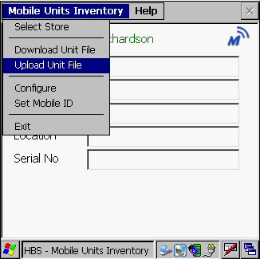
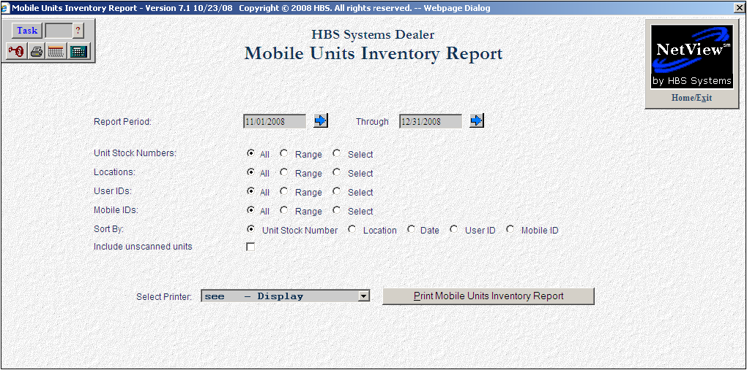
Run the Mobile Units Inventory Report for the unit inventory just completed. To access this report, select the following from the drop down menu:
Units / Reports / Mobile Units Inventory Report
Or type MUIR in the task box

Field Definitions

Report Period
Define the dates for the period of time to be included in this report. Choose a starting and ending date or use the arrow to the right to access a calendar.

Unit Stock Numbers
This selection lets you refine the details for the report. For the date range selected, you may choose all stock numbers, a range of stock numbers or up to six selected units.

Location
For the date range selected, you may choose all locations, a range of locations or up to six specific locations.

User Ids
For the date range selected, you may choose all user ids, a range of user ids or up to six specific user ids.

Mobile Ids
For the date range selected, you may choose all mobile ids, a range of mobile ids or up to six specific mobile ids.

Sort By
Choose the method of sorting for the report –stock number, location, date, user id or mobile id.

Select Printer
Select the printer to receive the printout. A default printer name is pre-filled but can be changed as necessary using the pull-down menu. Use the see printer to view the report on the screen without printing a copy of it.

Print Mobile Units Transaction Report (Alt P)
Press this button to print the report.

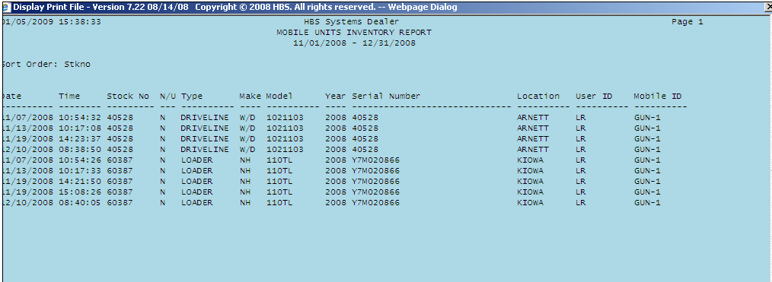
Example of Mobile Units Inventory Report sorted by Stock Number

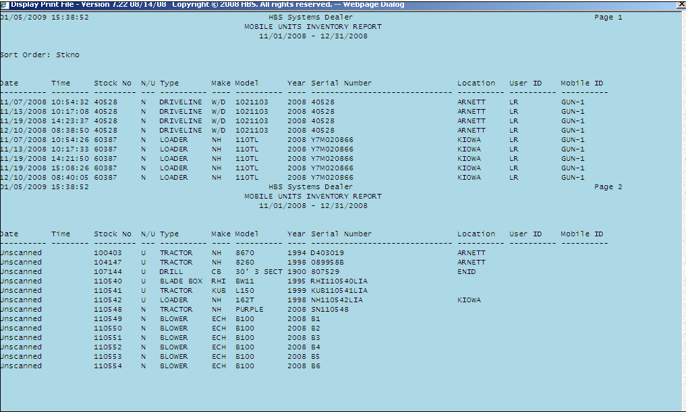
Example of Mobile Units Inventory Report showing unscanned wholegoods.

Report Fields

Report Period
This shows the date range selected for the report.

Sort Order
This is the sorting selection for the report.

Date
The date shown is when the inventory was taken.

Time
This shows the time of day the inventory was taken.

StockNumber
This is the stock number that was counted.

N/U
The status of the unit shows here – N-New, U-Used, R-Rental, O-Ordered.

Type
This field identifies the type of equipment.

Make
This is the manufacturer of the unit.

Model
This field shows the model number of the piece of equipment.

Year
This is the model year of the unit.

Serial Number
This is the serial number for the unit.

Location
For multi-location stores, this field likely shows where the unit is located.

User ID
This is the logon of the person who took the inventory.

Mobile ID
This is the identification assigned to the Mobile Unit.

